Shivam Navnath Giri  
CDAC SILCHAR PGDAI   
ASSIGNMENT 2  
Topic:DOCKER

SUBMIT via SCREENSHOTS

1. Create your image with dockerfile.

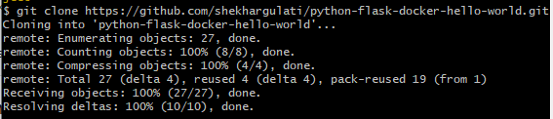  
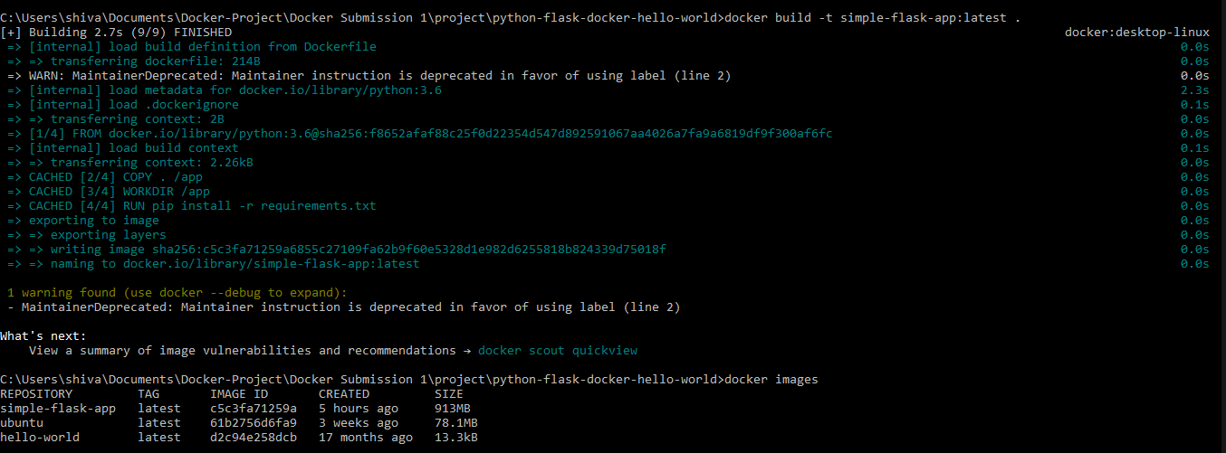

1. Build and deploy your application in the Docker.

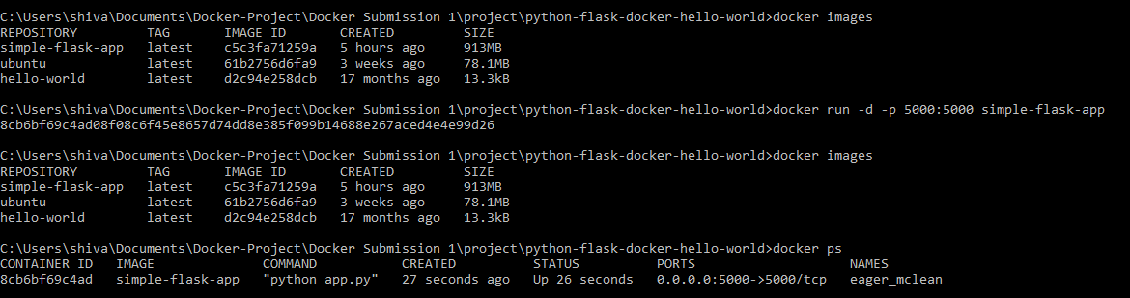

Executed code successful on port : 5000

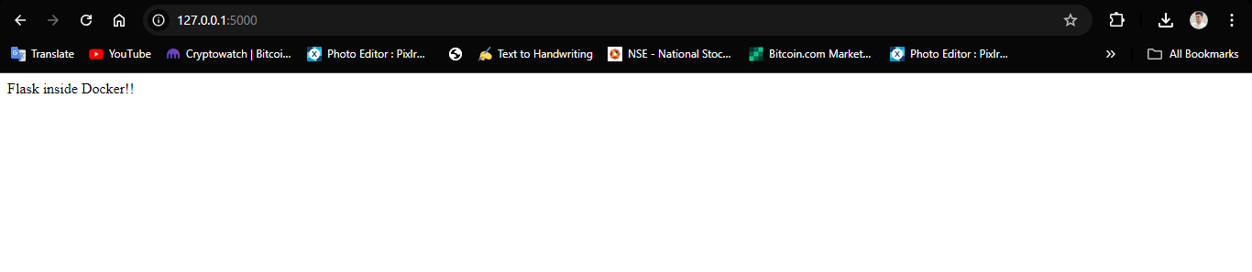

1. Push your image into Docker hub as public repository.

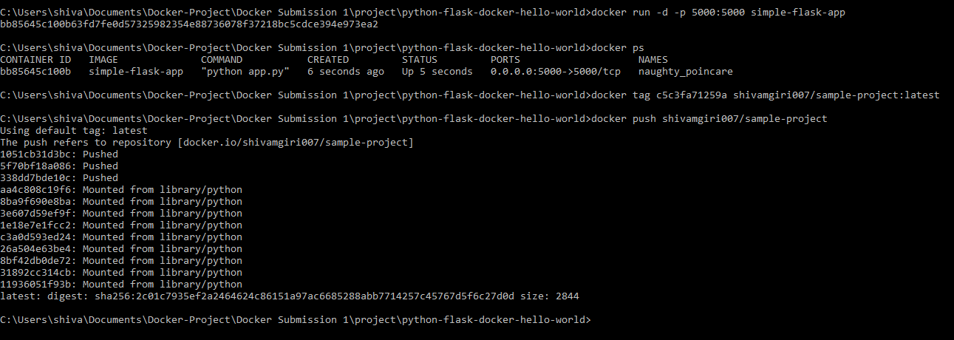

1. Run the commands on Docker terminal

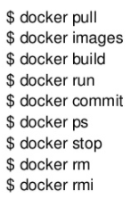

Docker pull

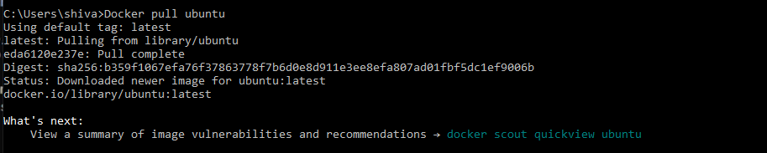

docker images

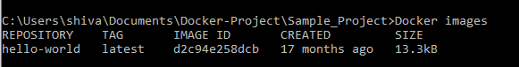  
Docker build

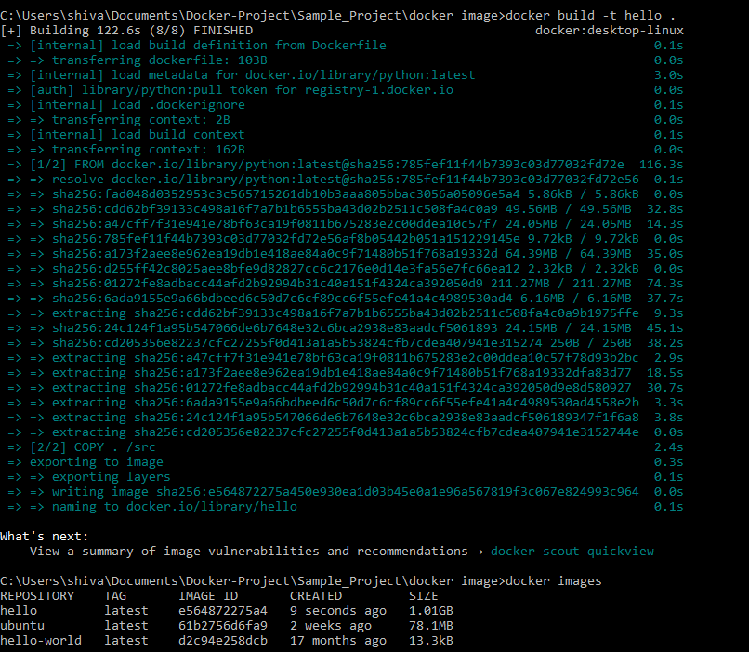  
docker run

C:\Users\shiva\Documents\Docker-Project\Sample_Project\docker image\run docker image file.png

Docker commit

C:\Users\shiva\Documents\Docker-Project\Sample_Project\docker commit.png

Docker ps

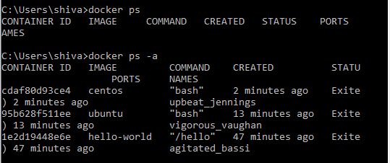

Docker stop

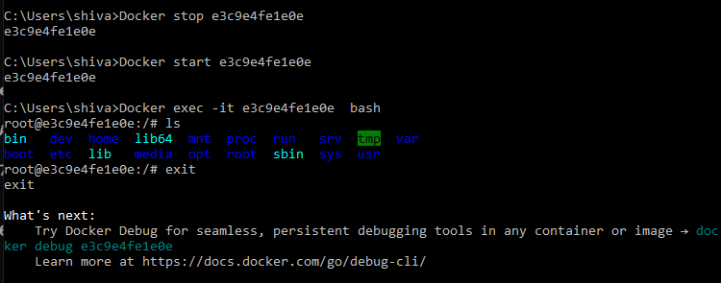

Docker rm

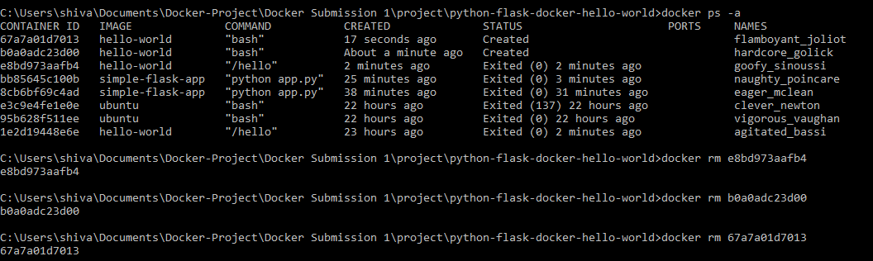

Docker rmi

